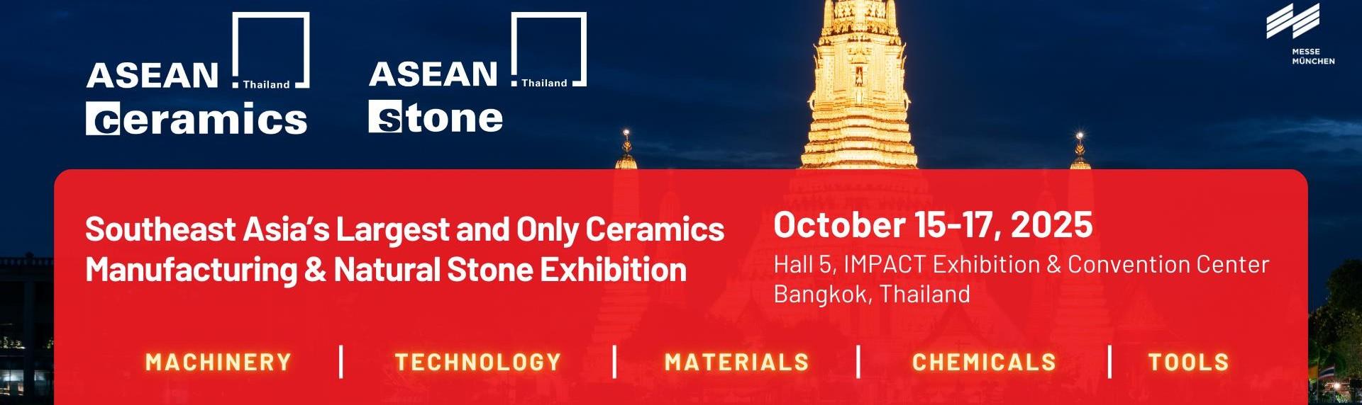

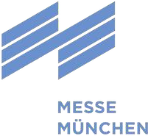

To make a copy & return this form to:
MMI Asia Pte Ltd
Ms. Valerie Fang Ms. Siegli Bacudio
valerie.fang@mmiasia.com.sg siegli@mmiasia.com.sg DEADLINE: 15 SEPTEMBER 2025
F O R M 3 PRE-EVENT TECHNICAL TOUR – FACTORY VISIT

EXHIBITOR / CONTRACTOR Billing Address: same as "Exhibitor" ☐ or

Company Company

Street / PO Box Street / PO Box

Country / City / Postal Code Country / City / Postal Code

Phone with Country & Area Code Phone with Country & Area Code

Email (personal Email address for confidential data, no “info@...”, etc.) Email (personal Email address for confidential data, no “info@...”, etc.)

Tax ID (For Thai company only) Tax ID (For Thai company only)

Hall and Booth No. Hall and Booth No.

Specially organized for our exhibitors, the pre-event factory tour offers participants a unique opportunity to embark on a guided journey, providing valuable insights into Thailand's national manufacturing landscape and firsthand information on ceramic technologies.

In this edition, the tour will encompass visits to some of Thailand’s most prominent ceramics factories, showcasing the expertise of leading manufacturers in the country.

The tour will be organized on 14 October 2025 and offered to a maximum of 30 guests to visit the production sites, on a first-come, first-serve basis.

Factory 1 - Morning | Factory 2 - Afternoon
The Siam Refractory Industry Co., Ltd  1 Moo 9, Huai Bong-Thalarn Road, Bankrua, Banmor, Saraburi 18270, Thailand.  Note: Lunch will be hosted by SCG | Compound Clay Thailand  99/1 Moo 2 Asia Rd. Banmor, Phromburi, Singburi 16120

Important Information:
- Departure time: 07:30 a.m. sharp
- Pick-up point: Hall 5, IMPACT Exhibition & Convention Centre, Bangkok
- Check-in: Please arrive at least 15 minutes prior to departure for registration and preparation.

The prominent guests, exhibitors and media group will be taken on a trip to visit the factory, followed by lunch.
A payment of USD$100 per participant is required to cover the cost of lunch and a coach transfer to ensure commitment to the tour.

Contact person:
- Kathy Pham - Project Manager
- Email: kathy@aseanceramics.com; WhatsApp mobile +84 90 390 49 03
- Email: aseanceramics@mmiasia.com.sg; WhatsApp mobile +65 8712 3652

No. of participant(s) ______ x USD100 / participant = __________________________
Pre-event technical tour is only open to exhibitors of ASEAN Ceramics only.

Name: Signature:
___________________________ ______________________________

Payment: Stripe
Link: https://buy.stripe.com/fZu14m5cGf6Jglh9YNffy0a



